MEDIACODER YURAKU USER GUIDE

- Installation

To install MediaCoder Yuraku Edition, run “MediaCoder_Yuraku_Setup.exe” and follow the instructions given during the setup.

Note: During the installation, you will be prompted to install FireFox internet browser. It is needed to run MediaCoder. If you have FireFox installed in your computer, you may skip the FireFox installation.

- Using MediaCoder

a. From your Desktop, click on the MediaCoder shortcut to run the program.

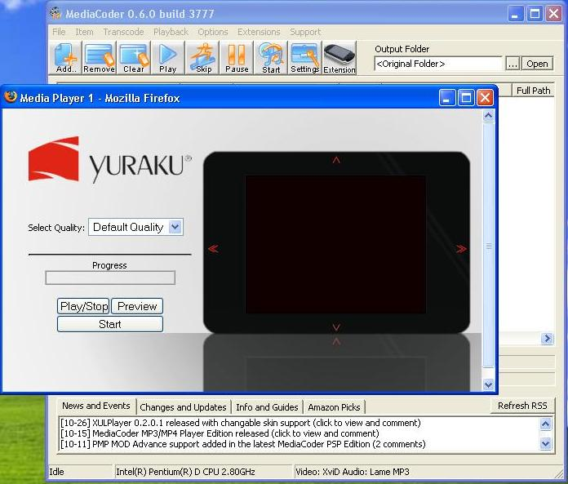
Figure 1. MediaCoder at start up

b. To add a file, simply drag the file and drop it into the main window.

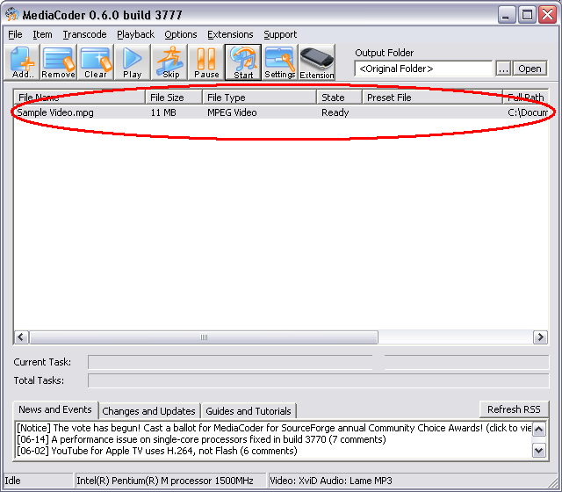
Figure 2. The Main window

c. Choose the desired quality in the extension window and click on the “Start” button.
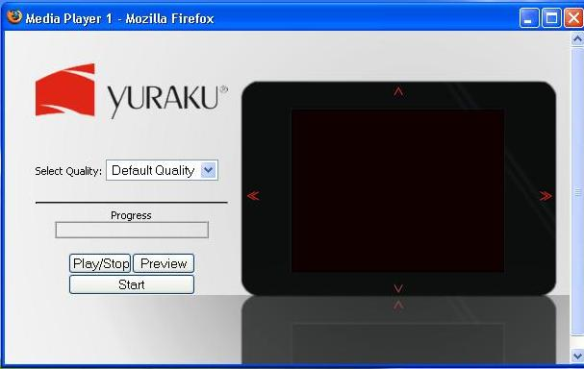
Figure 3. The Extension window

The output file will be created in the same folder as the original file.

- Troubleshoot

For trouble shooting, refer to the “Troubleshoot.doc” file in the MediaCoder directory.

